**State Transition Diagram Testing for User Login**

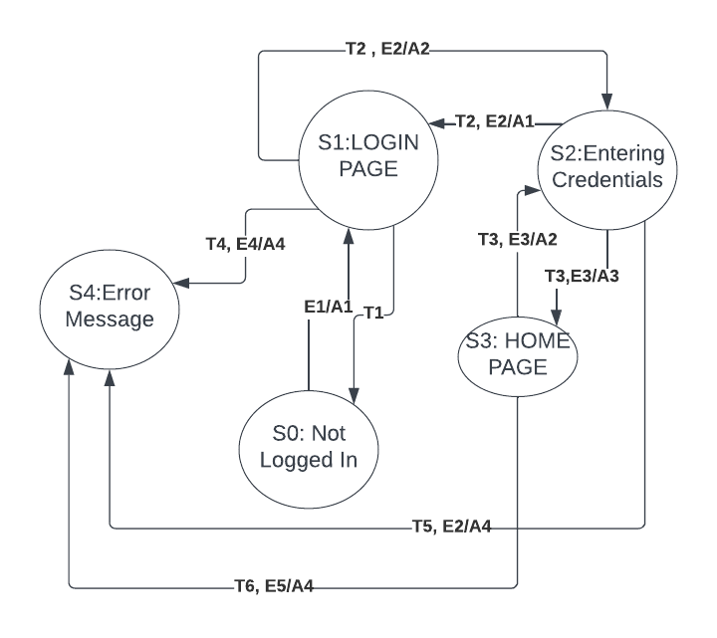

**States:**

**Initial State (S0): User is not logged in.**

**State 1 (S1): User is on the login page.**

**State 2 (S2): User has entered valid login credentials.**

**State 3 (S3): User login is successful, and they are redirected to the home page.**

**State 4 (S4): User login is unsuccessful, and an error message is displayed.**

**Transitions:**

**T1: Transition from S0 to S1 occurs when the user navigates to the login page.**

**T2: Transition from S1 to S2 occurs when the user enters valid login credentials and submits the form.**

**T3: Transition from S2 to S3 occurs when the system verifies the credentials and logs in the user successfully.**

**T4: Transition from S2 to S4 occurs when the system identifies invalid credentials, and an error message is displayed.**

**T5: Transition from S4 to S1 occurs when the user decides to try logging in again after an unsuccessful attempt.**

**T6: Transition from S3 to S0 occurs when the user logs out.**

**Actions:**

**A1: Display login page.**

**A2: Verify login credentials.**

**A3: Redirect to home page.**

**A4: Display error message.**

**A5: Display home page.**

**A6: Logout.**

**Events:**

**E1: User accesses the login page.**

**E2: User submits login credentials.**

**E3: Successful login.**

**E4: Unsuccessful login.**

**E5: User clicks logout.**